A Course Work Project Report

*on*

“Virtual Plasma Bank”

*by*

|  |  |  |  |  |
| --- | --- | --- | --- | --- |
| **Sr.no** | **Name** | **PRN no.** | **Roll no.** | **Seat no.** |
| 1 | Rohit Suryawanshi | 0120180155 | 112 | T204025 |
| 2 | Kunal Zope | 0120180032 | 131 | T204006 |
| 3 | Pranjal Rai | 0120180412 | 135 | T204060 |
| 4 | Shubham Sapkal | 0120180257 | 091 | T204043 |

*of*

**IT307: Web Technology**

**T.Y. BTech**

**Academic Year: 2020-2021**

**School of Computer Engineering & Technology**



**Contents**

|  |  |  |  |
| --- | --- | --- | --- |
| **Sr. No.** | **Topic** | | **Page No.** |
| **Chapter-1** | **Introduction** | |  |
|  | 1.1 | Objective |  |
|  | 1.2 | Introduction to Project |  |
|  | 1.3 | Features |  |
|  | 1.4 | Benefits |  |
| **Chapter-2** | **Database Design** | |  |
|  | 2.1 | Introduction |  |
|  | 2.2 | Database design |  |
| **Chapter-3** | **API/Library** | |  |
|  | 3.1 | Introduction |  |
|  | 3.2 | Usage in project |  |
| **Chapter-4** | **Results (Screen shots)** | |  |
| **Chapter-5** | **Conclusion** | |  |
|  | **References** | |  |

**Chapter 1**

**Introduction :**

* 1. **Objective**
* To Administer standards programs that ensure the quality and safety of plasma collection and protect both donors and Patients.
* To advocate for access to the affordability of therapies for patients.
* To become the bridging gap between the Donor and Patient.
* To collaborate with Patient advocacy Organisation.
* To fight Corona Pandemic.
  1. **Introduction to Project**

Online Plasma Bank system: This is an online project developed using Php and MySQL. The purpose of this project is to provide plasma to those in immediate need of it, in minimal time and at ease. There are 2 different types of users, the individual user and the organizational user. ‘Organization’ here stands for blood/plasma bank or hospital. Both users can list themselves for blood donation. Key difference between them is that if an organization is registered, they are given priority over independent donors.

This Website is user friendly and helps in finding donors sooner rather than wandering manually everywhere from hospital to hospital.

If any good feedback will be taken positively and if any negative feedback too will be taken positively and try to improve what had lacked. The report is also generated periodically and the database will be cleared according to the time span for faster performance.The website developed for the Online Plasma Bank system is powered by HTML/ CSS, PHP as front-end & MYSQL EXPRESS as back-end. It is an application which decreases few efforts of searching for a verified donor or nearest blood bank in urgency.

We had Generalised our Website as created below :

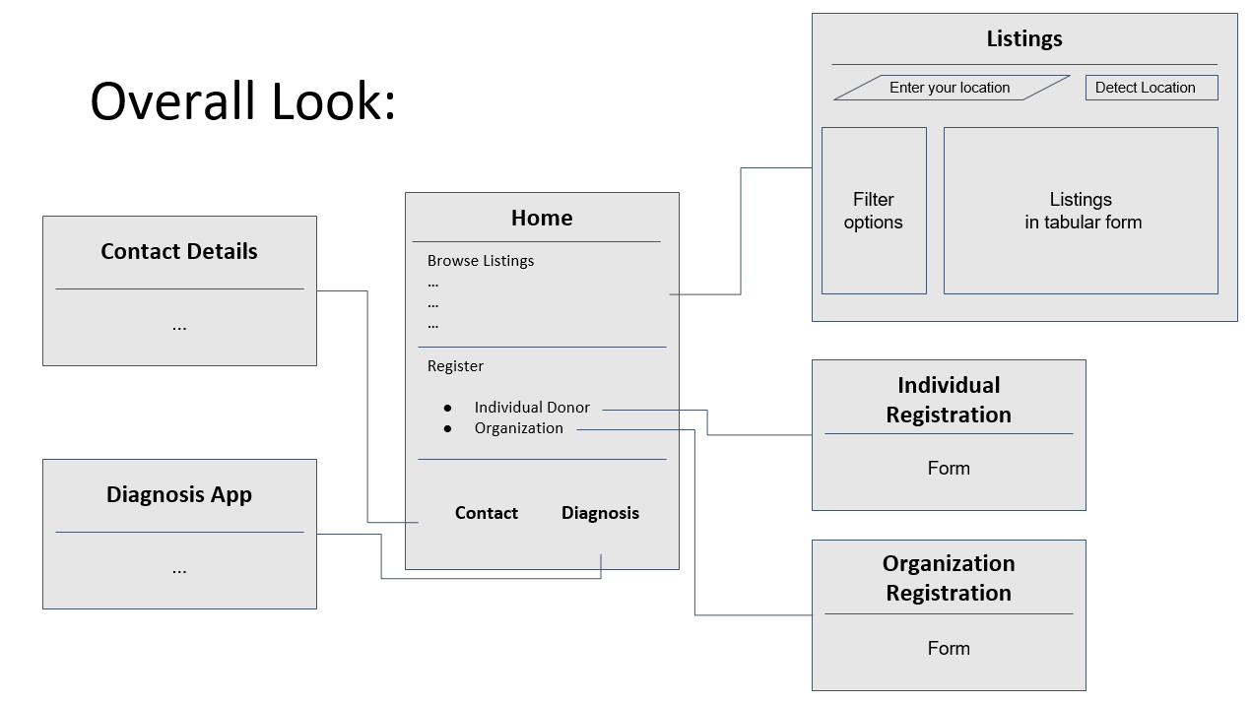

* 1. **Features:**

Online Plasma Bank is a complete solution that delivers features most requested by hospitals and patients of chronic health conditions.

1.3.1 Anyone-Anywhere-Anytime

All functions are secure, intuitive and user friendly, and can be operated by non-technical persons at any time, from any remote location, with an Internet connection and Web browser. A high speed Internet connection is not required.

1.3.2 Eliminate Outdated Site Content.

Online Plasma Bank ensures that only valid information appears on your search since we keep in touch with registered donors and take updates from them regularly.

* + 1. Core Features.

1. Email Authentication

All users are verified with proper credentials and a valid email address.

1. Email-Notifications using PHP-Mailer
   1. Mail regarding the appointment scheduling.
   2. Fault in the application form of donor/receiver.
   3. To send the link for verification and change password.
2. Easy Application process to donate and receive plasma.
   1. User need to answers some questions at the time of submitting donar application to check the medical history of donar.
   2. Id proof like aadhar/PAN card will be taken from the user to verify the identity of the user.
3. Administrator Panel
   1. Verifies the user identity.
   2. Handles all the donor/receiver requests
   3. To approve the plasma bank the approval from the state territory licensing authority is checked.
   4. Checks the medical history of the user and finds out whether the user is eligible to donate a plasma.
4. Well Scheduled appointments

Plasma bank will provide the detail of appointment timing and date for donor/receiver after the user verification of identity and application form is being done by the admin panel.

1. User Friendly GUI
   1. **Benefits**

a) Minimal browsing time and more accurate data for Donor/Bank location.

b) Easy to use UI even for technically-illiterate users.

c) Email-Notifications

d) Many other features and enhancements

**Chapter 2**

**Database Design** 

* 1. **Introduction**

Database design is the process of producing a detailed data model of a database. This logical data model contains all the needed logical and physical design choices and physical storage parameters needed to generate a design in a Data Definition Language, which can then be used to create a database. A fully attributed data model contains detailed attributes for each entity.  
The term database design can be used to describe many different parts of the design of an overall database system. Principally, and most correctly, it can be thought of as the logical design of the base data structures used to store the data. In the relational model these are the tables and views. In an object database the entities and relationships map directly to object classes and named relationships. However, the term database design could also be used to apply to the overall process of designing, not just the base data structures, but also the forms and queries used as part of the overall database application within the database management system (DBMS).

* 1. **Database Design**

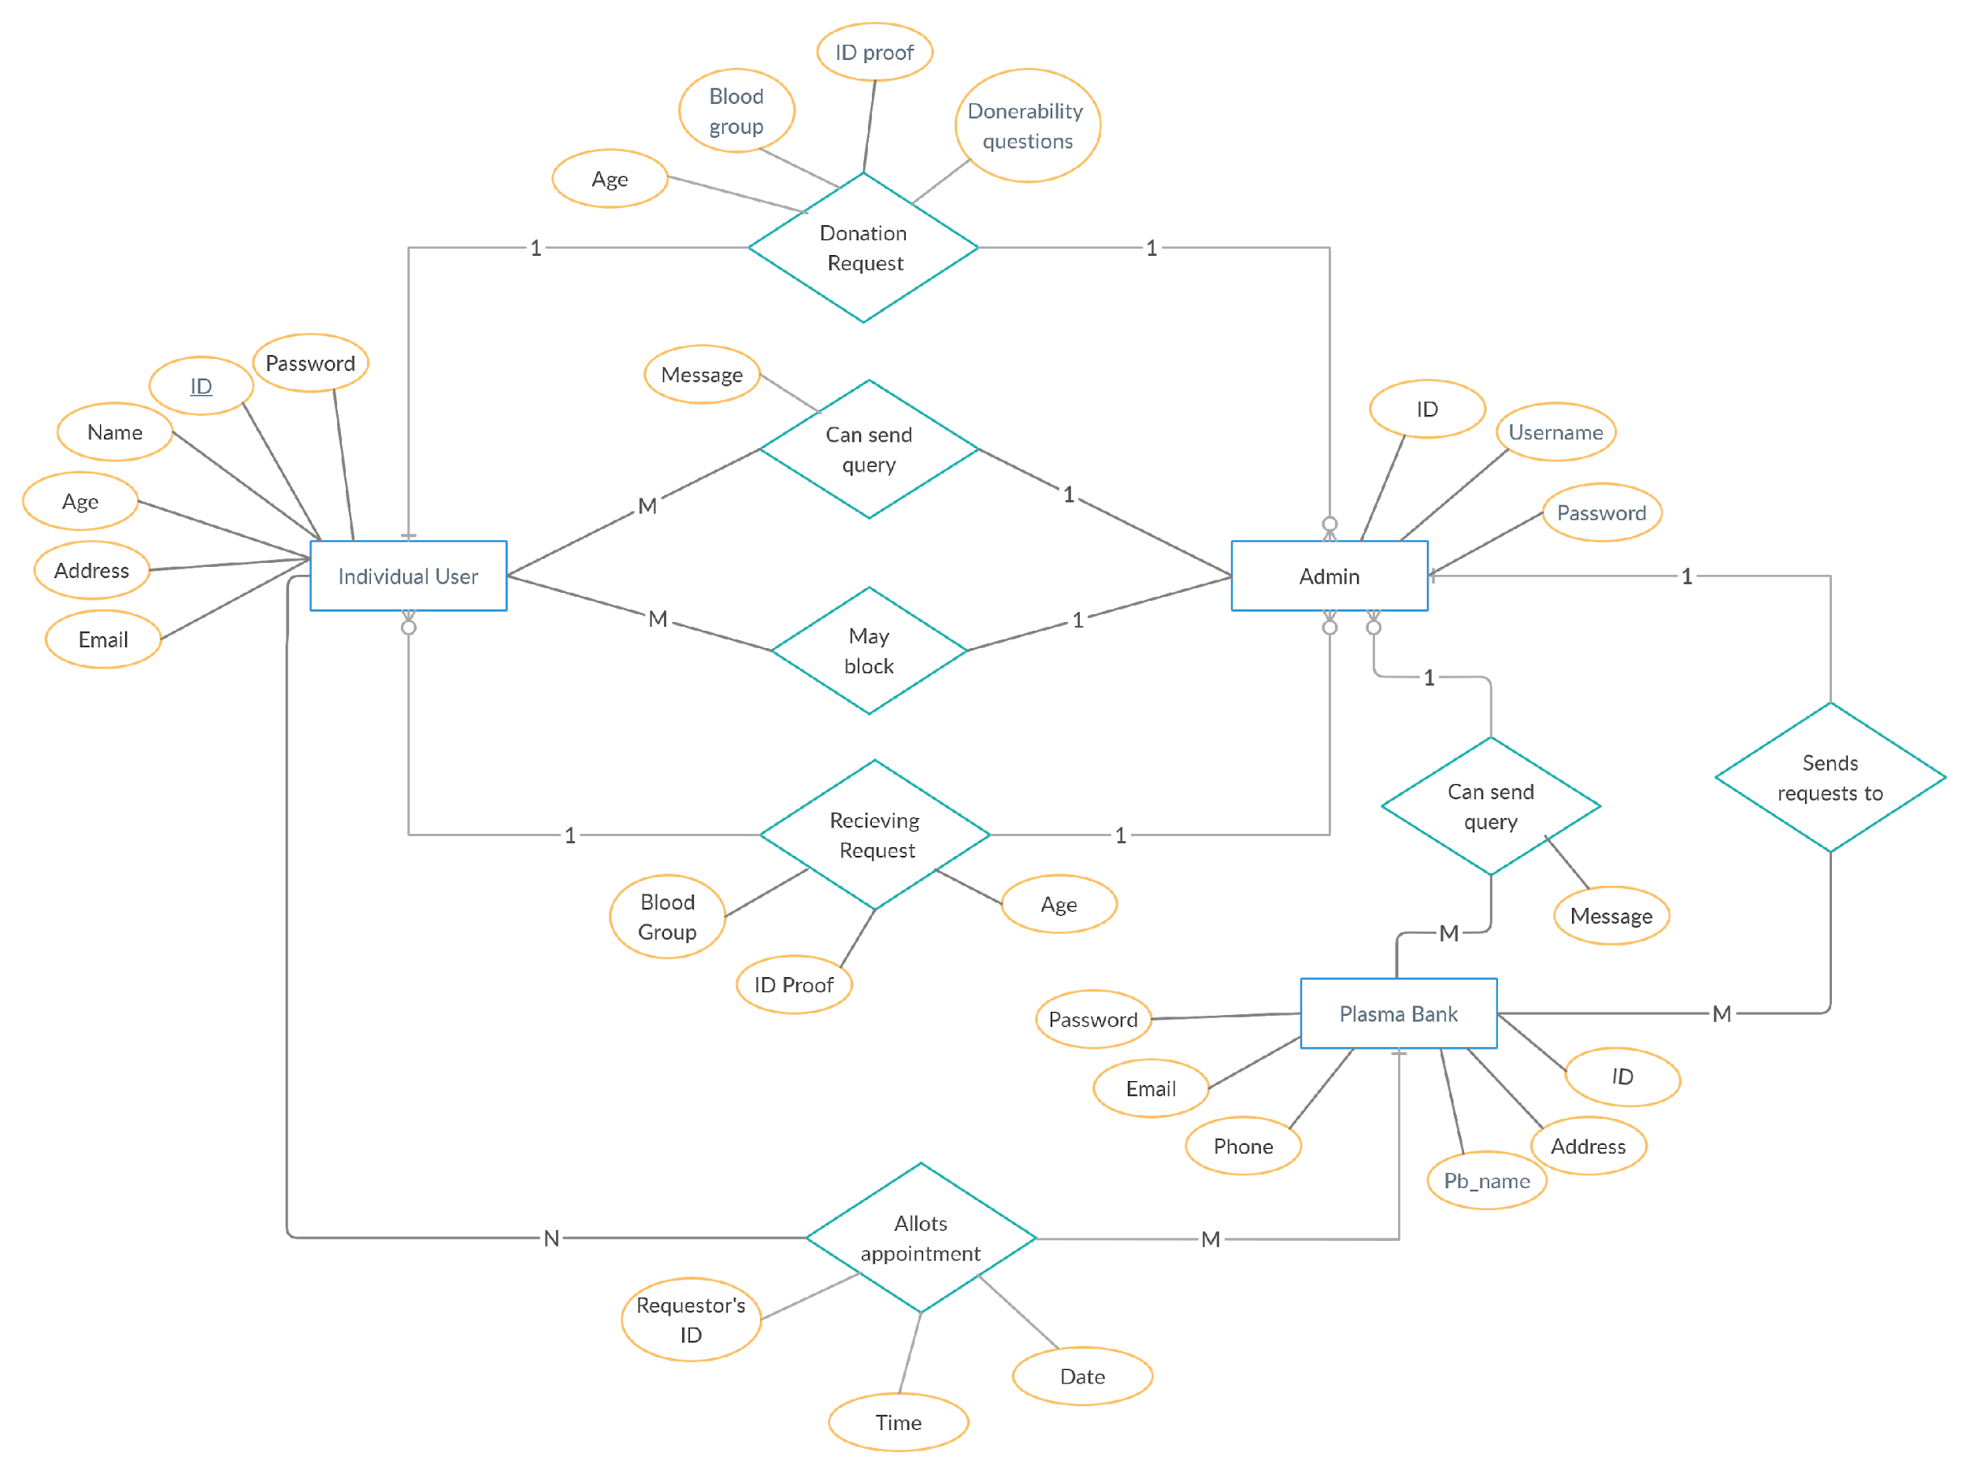

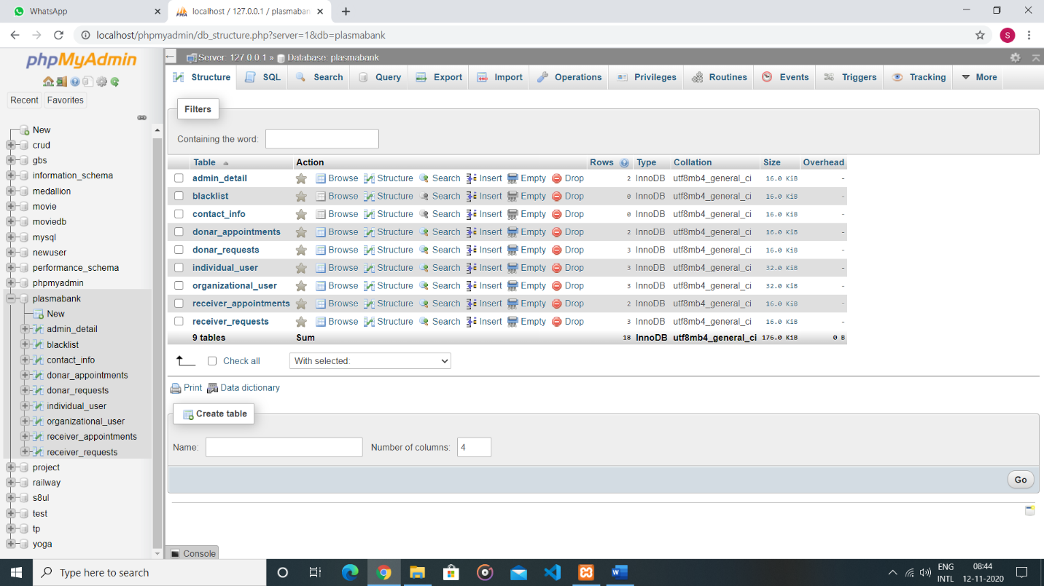

Fig : All Database

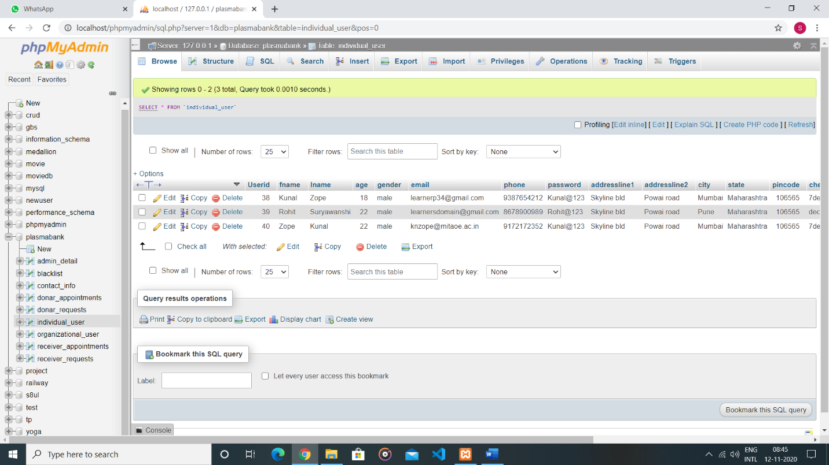

Fig : User Table

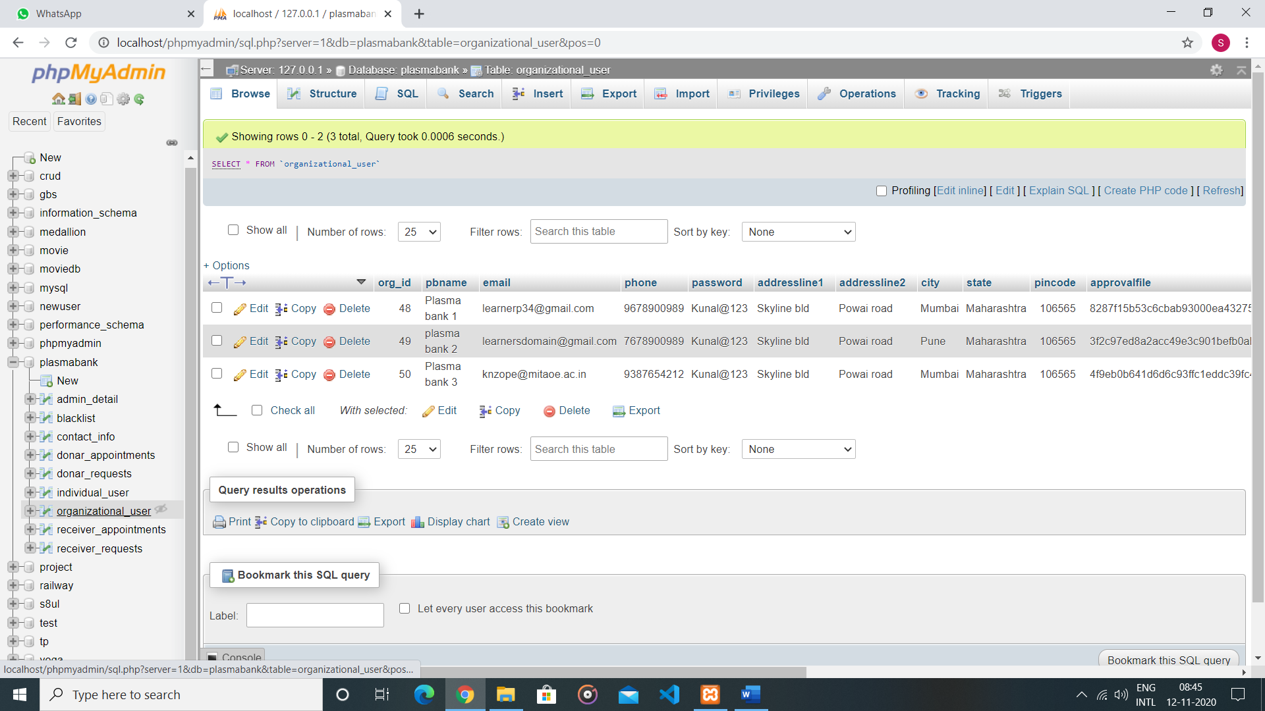

Fig : Plasma Bank Table

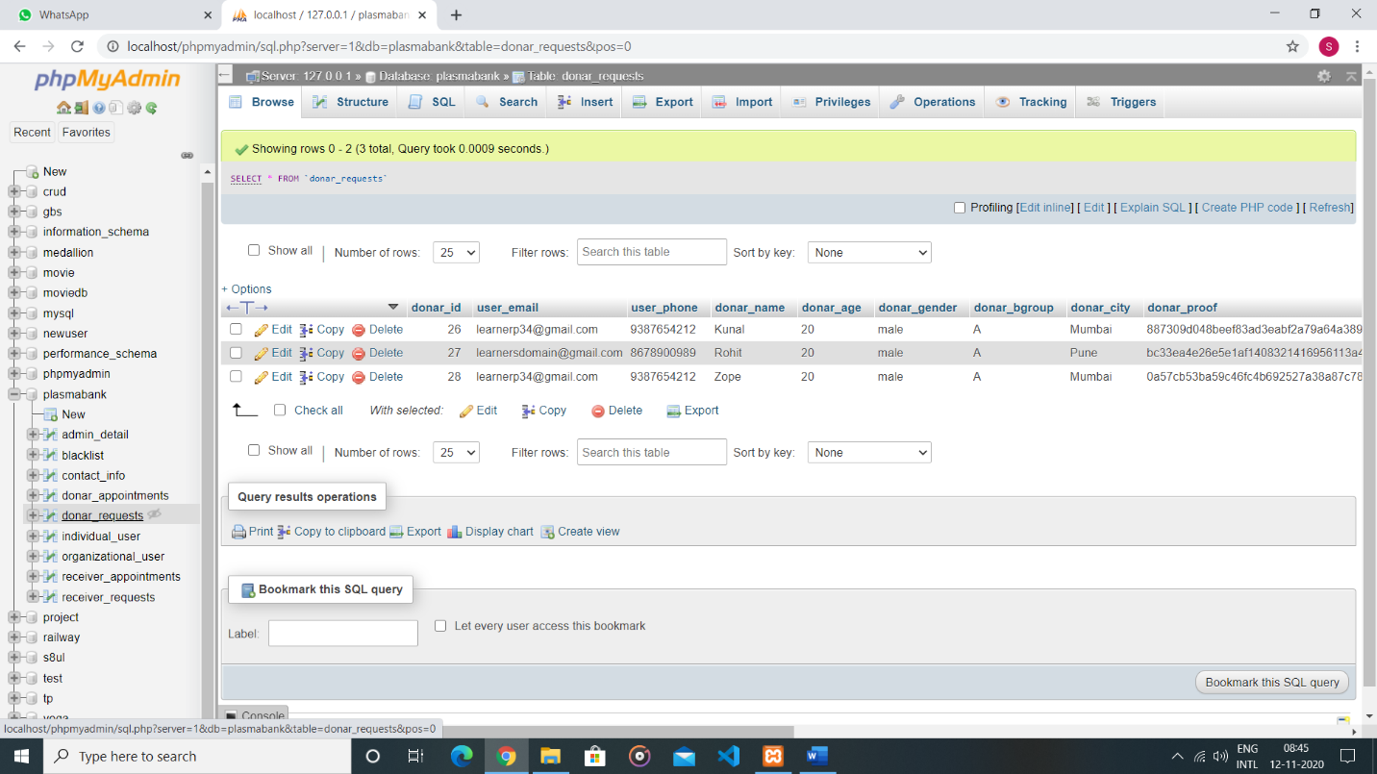

Fig : Donar Requests table

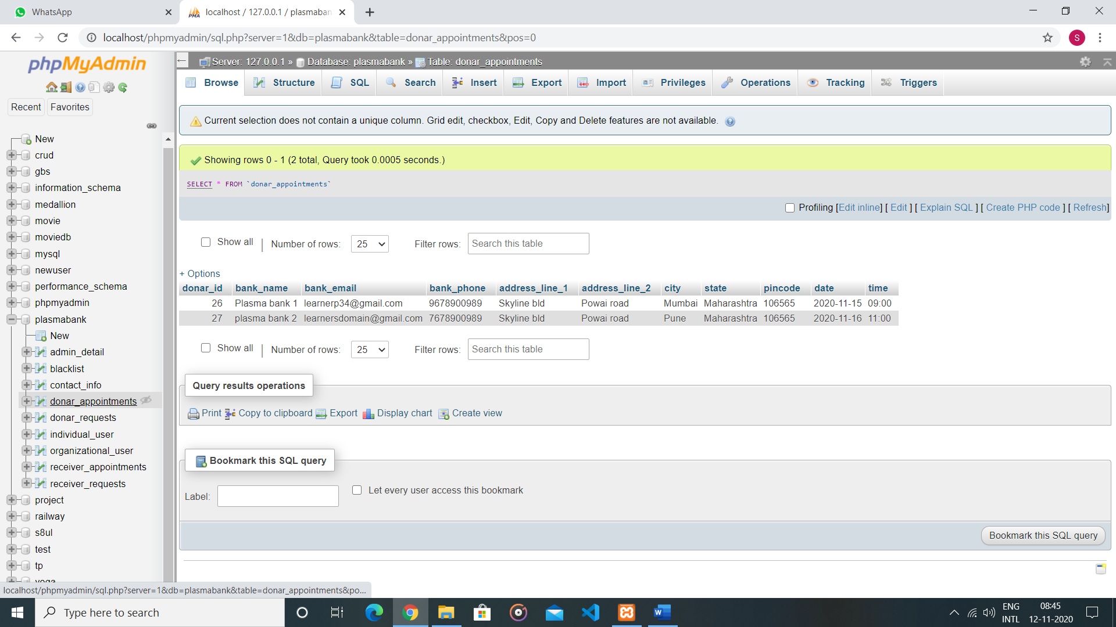

Fig : Donar Appointment table

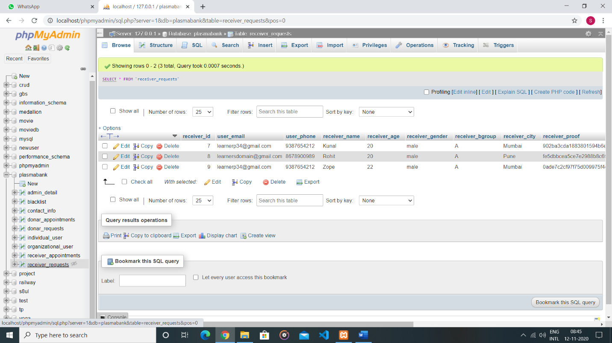

Fig : Receiver requests table

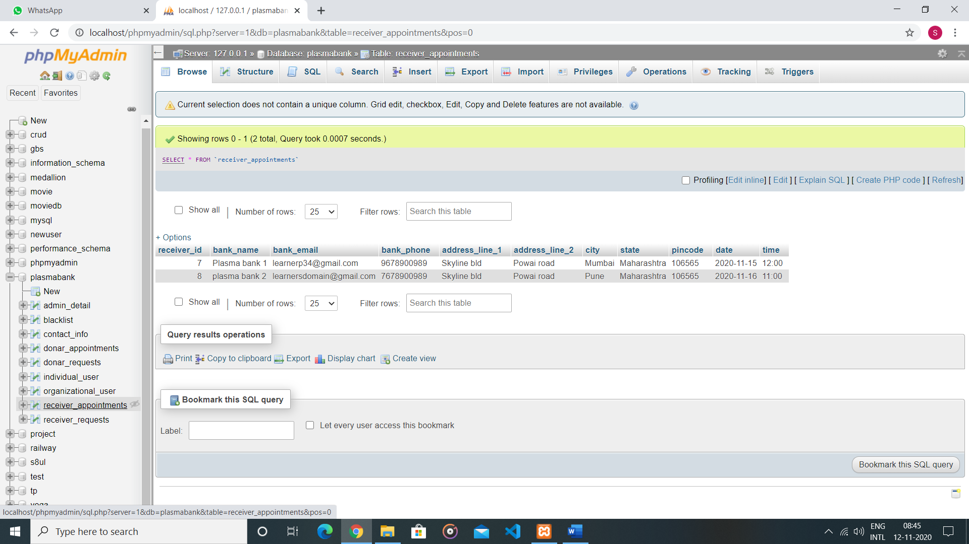

Fig : Receiver Appointment Table

**Chapter 3**

**API/Library** 

* 1. **Introduction**

An application programming interface (API) is a computing interface which defines interactions between multiple software intermediaries. It defines the kinds of calls or requests that can be made, how to make them, the data formats that should be used, the conventions to follow.

An API (Application Programming Interface) is a set of functions that allows applications to access data and interact with external software components, operating systems, or microservices. To simplify, an API delivers a user response to a system and sends the system's response back to a user.

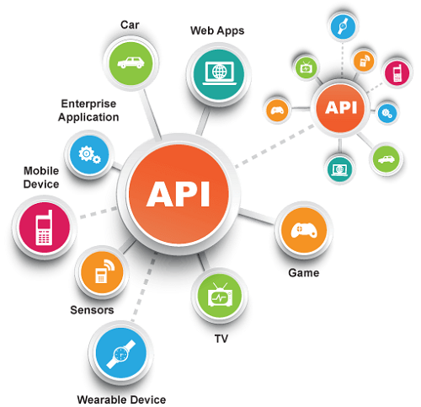

**Fig no. 1: Introduction of API**

* 1. **Usage in Project**

**PHPMailer**



* It is used to send email-Notifications to the user about his application status and various events that plasma bank is going to organize.
* It is used for sending email to the user about the appropriate date and timing of the appointment.
* It is used by admin to send email to plasma bank and donar/receiver user to indicate fault int the application form.
* It is also used for sending the link for email authentication and change password.

**Chapter 4**

**Results/Screenshots** 

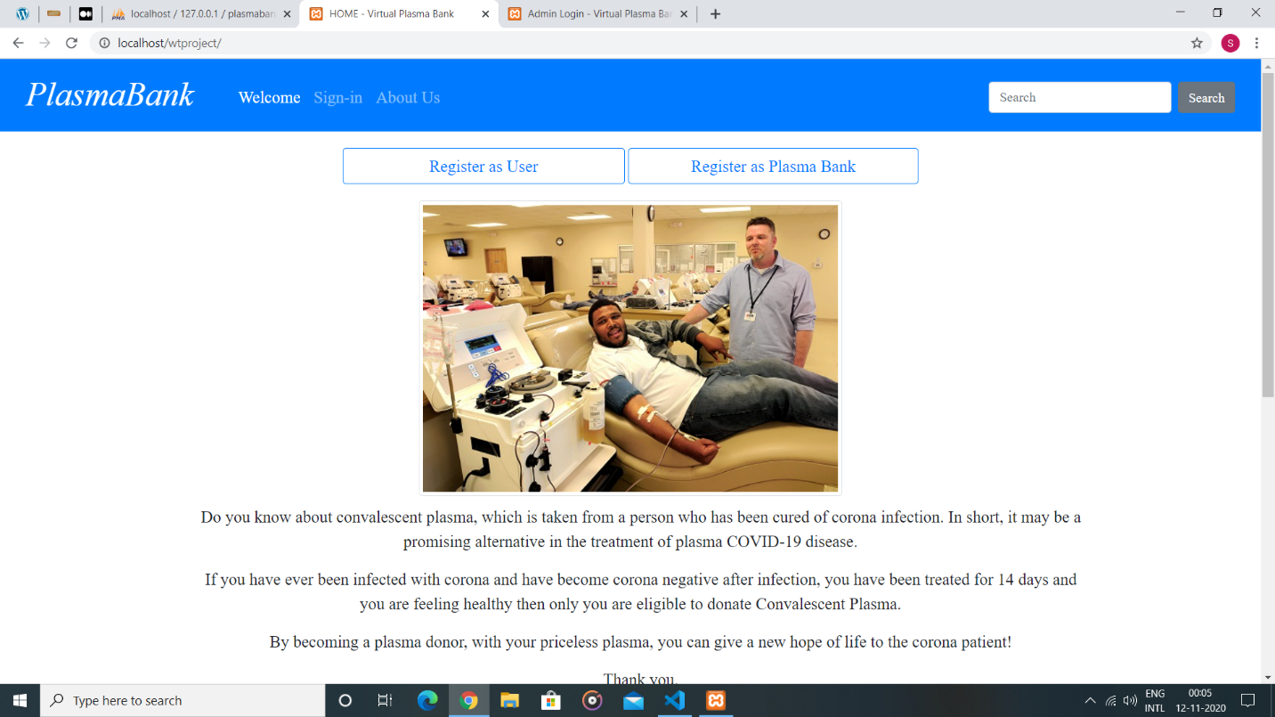Fig : Welcome Page 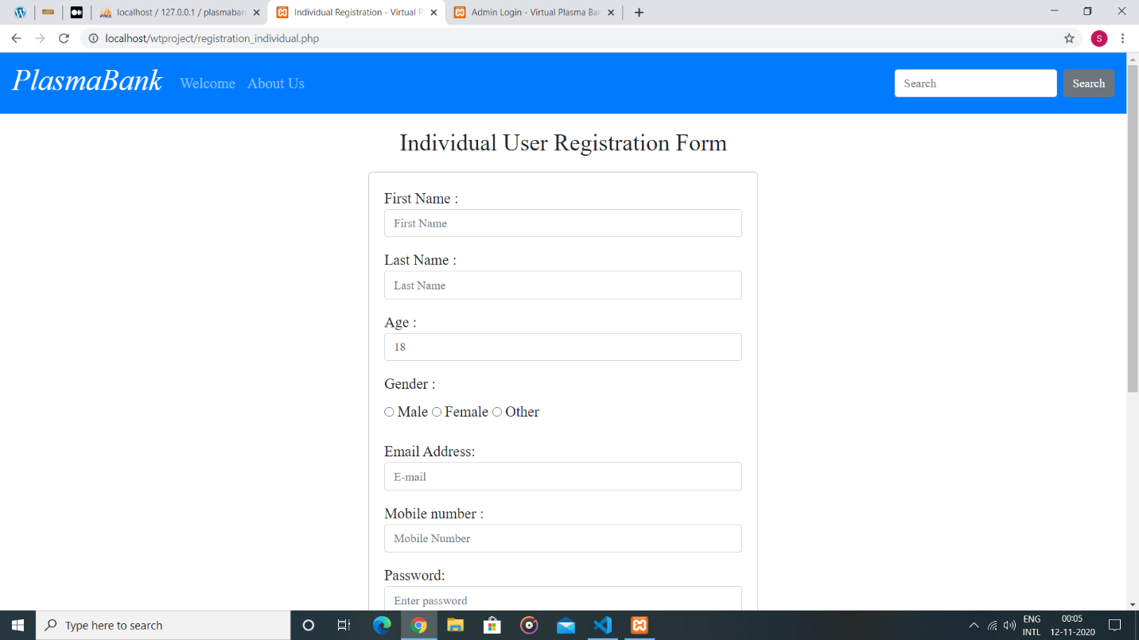 Fig : User registration form

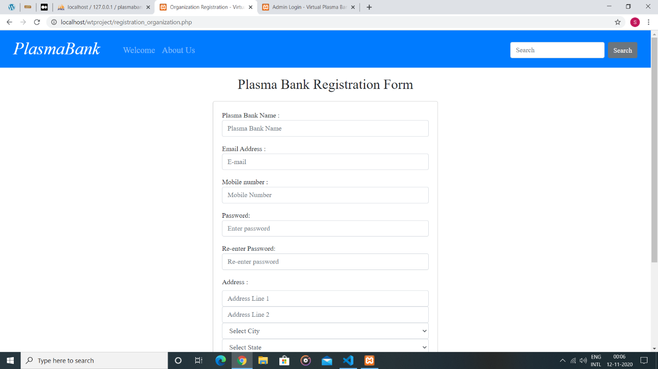Fig : Plasma Bank registration Form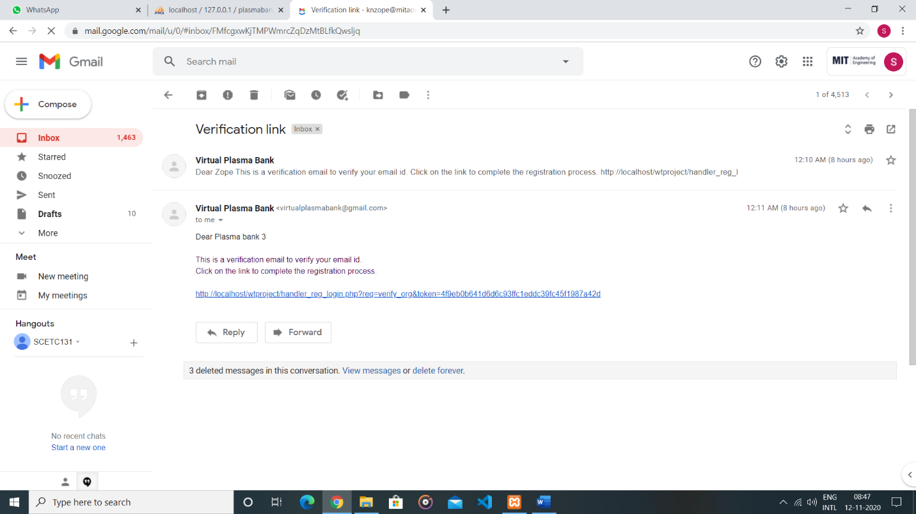Fig: Mail Sent using phpmailar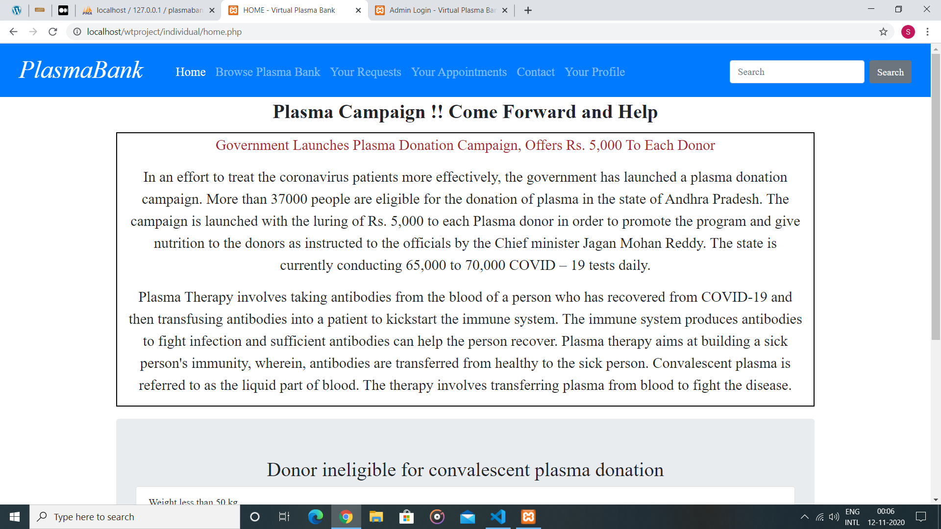Fig: User home page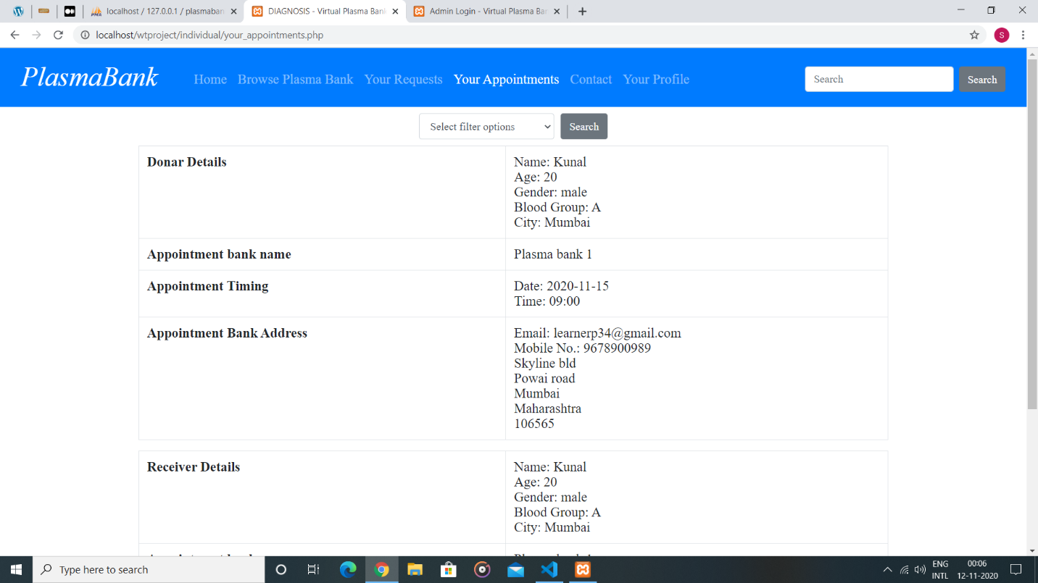Fig: User Appointment details page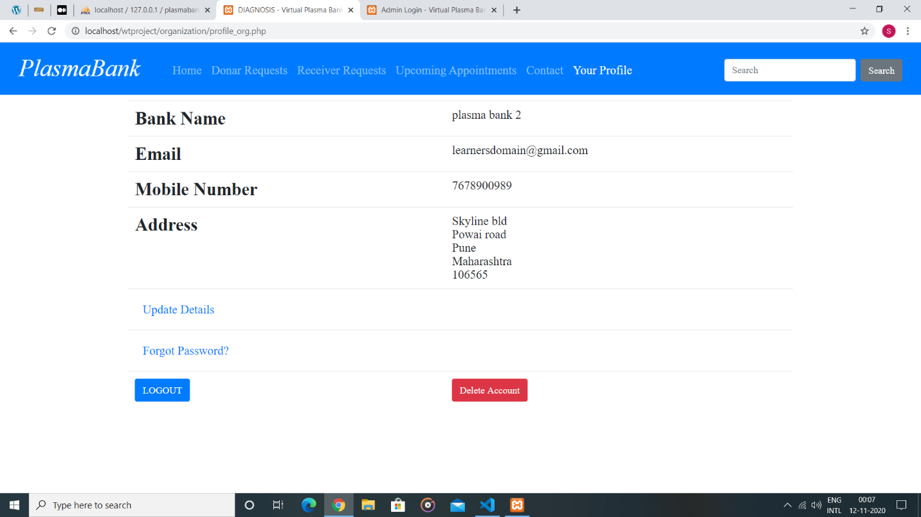Fig: Plasma Bank Profile

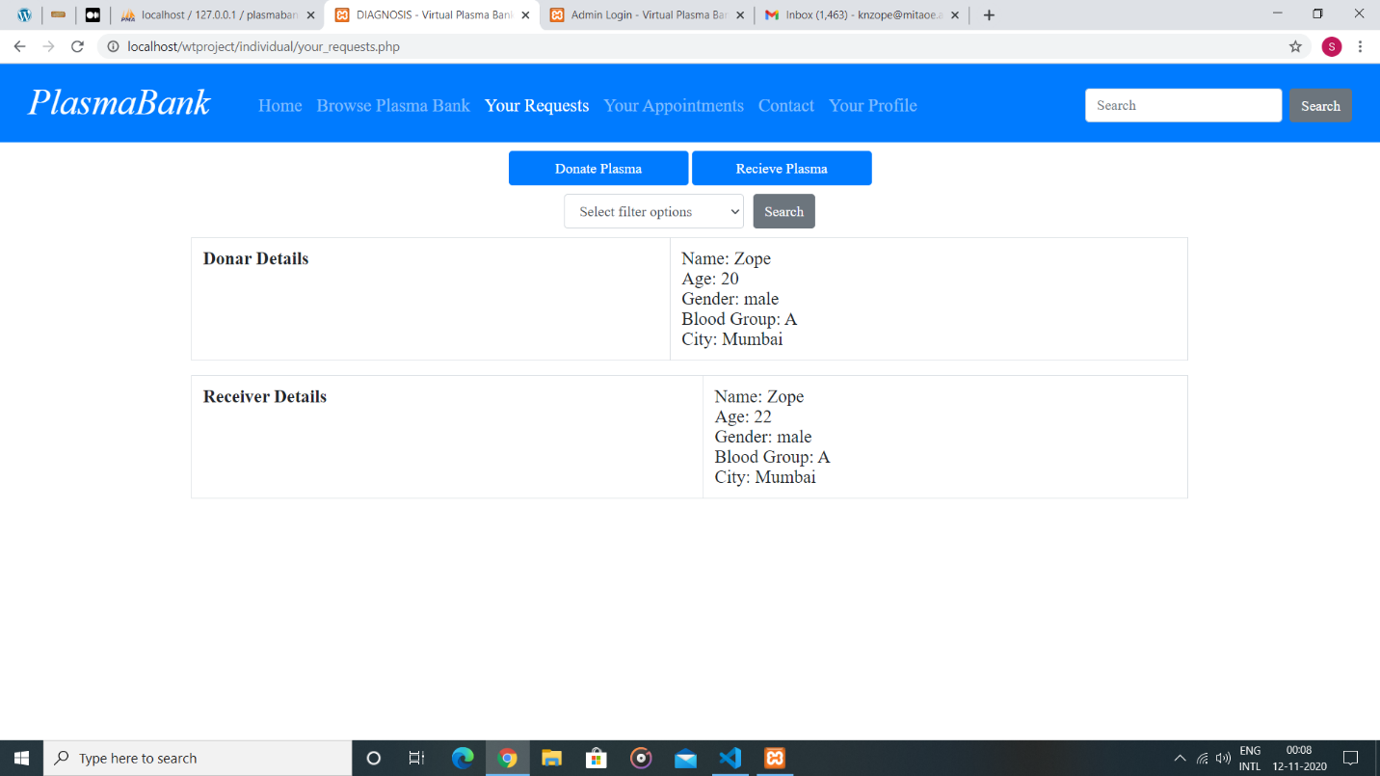

Fig: User Requests

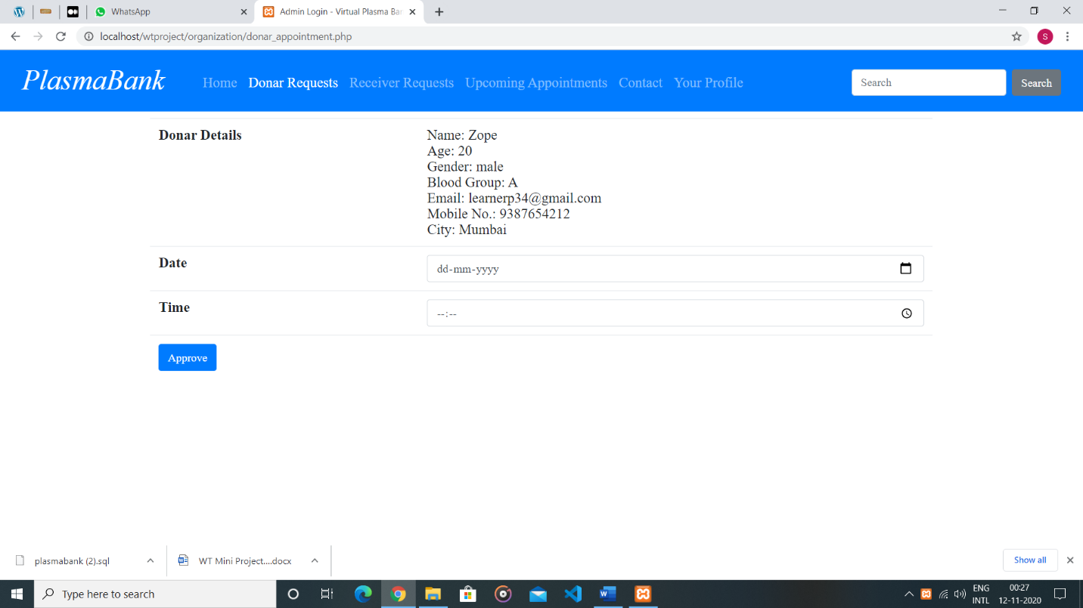

Fig: Plasma bank accepting donar requests

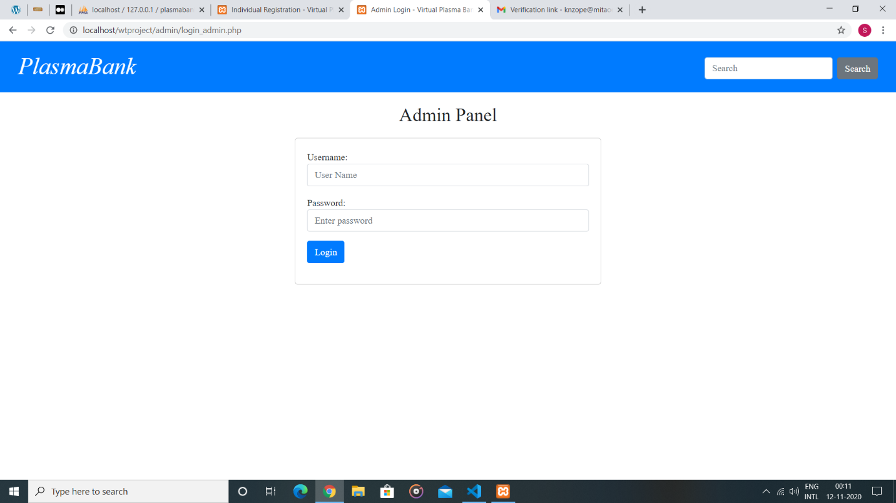

Fig: Admin Page

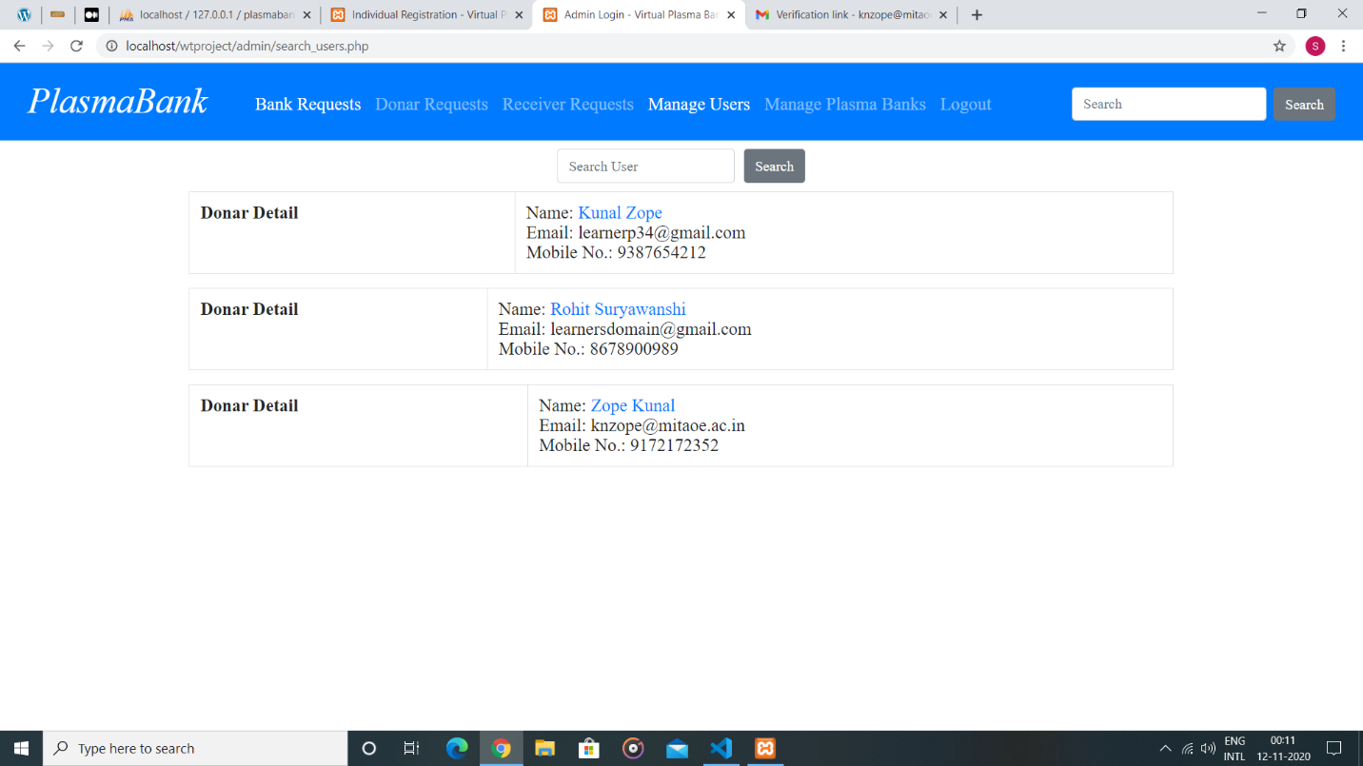

Fig: Manage user admin page

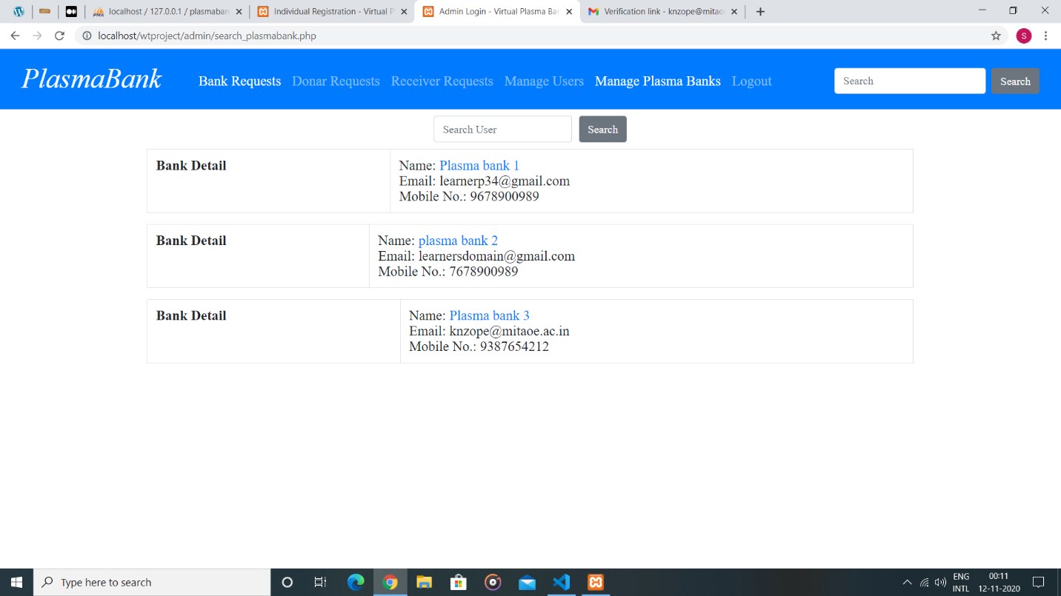

Fig: Manage Plasma bank admin page

**Chapter 5**

**Conclusion** 

In pandemic struck times, we are seeing a rise in health cases, and it can be crucial for hospitals or patients to get plasma donations for saving lives. On top of this, we are not as prone to going out from place to place on today's date, as we used to do before. Therefore, an online portal where we can contact nearest, verified donors through our computers or phones is very important.

The website will provide a appointment system where normal user (donar/receiver) and plasma bank can get themselves register and can use the features of website like application for donation or receive the plasma. The plasma bank will respond to the application and will provide the appropriate date and timing to the user so that user waiting time will get reduced. The website has a strong admin panel. Admin will verify the plasma bank approval from state territory authority and also verify the identity of user. The strict action has been taken about users and plasma banks who are misusing their accounts. Their account will get deleted and they will be added to blocklist.

This Website will be friendly and helps in finding donors sooner rather than wandering manually everywhere from hospital to hospital. The ultimate goal is to facilitate coordinated and well-informed system capable of maximum user satisfaction.

**References**

* https://www.cslplasma.com/
* https://www.ilbs.in/plasma/
* https://www.donatingplasma.org/
* <https://indianbloodbank.com/>
* https://www.hindawi.com/journals/jbt/2014/752182/